Amrita Vishwa Vidyapeetham Amrita School of Engineering, Coimbatore
20CYS315 AUTOMATA THEORY AND COMPILER DESIGN
B.Tech Cyber Security
23-12-2025
Set 1
- Build a DFA that accepts the set of strings over {a,b,c} in which the possible a’s precede the b’s, which in turn precede the c’s. It is possible that there are no a’s, b’s or c’s.
(4 mark)
- Let M be the deterministic finite automaton defined by
Q = {q₀,q₁,q₂}
Σ={a,b}
F={q₂}
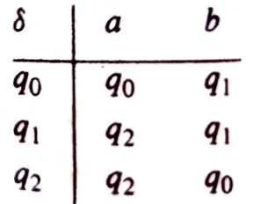

- Give the state diagram of M.
- Trace the computations of M that process the strings abaa, bbbabb, bababa and bbbaa.
- Describe the language that is accepted by the automata. (6 mark)

- Le t M be the NFA- ε. Convert the NFA- ε to NFA
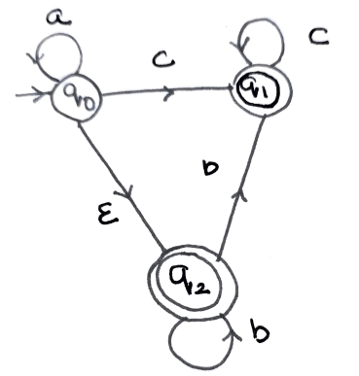 (5 mark)
- Minimize the following DFA
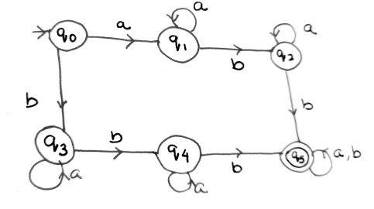
(10 mark)

Amrita Vishwa Vidyapeetham Amrita School of Engineering, Coimbatore
20CYS315 AUTOMATA THEORY AND COMPILER DESIGN
B.Tech Cyber Security
23-12-2025

Set 2
- Build a DFA that accepts the set of strings over {a,b,c} in which the number of a’s is divisible by three. (4 mark)
- Let M be the deterministic finite automaton defined by
Q = {q₀,q₁,q₂}, F={q₀}, Σ={a,b}

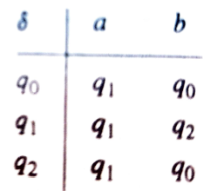
- Give the state diagram of M.
- Trace the computations of M that process the string babaab.
- Describe the language that is accepted by the automata.
- mark)

- Convert the following NFA- ε to NFA

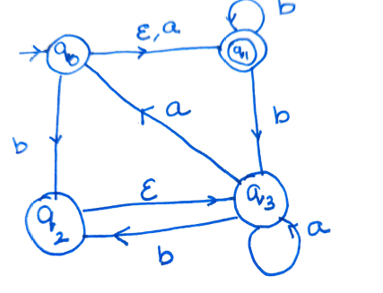
(5 mark)
- Minimize the following DFA
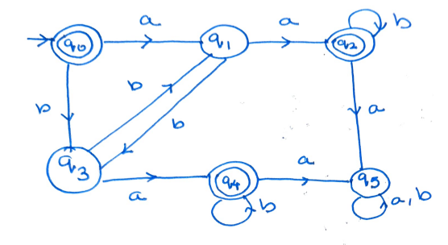(10 mark)

Amrita Vishwa Vidyapeetham Amrita School of Engineering, Coimbatore
20CYS315 AUTOMATA THEORY AND COMPILER DESIGN
B.Tech Cyber Security
23-12-2025

Set3
- Build a DFA that accepts the set of strings of odd length over {a,b} that contain the substring bb. (4 mark)
- Let M be the DFA with state diagram.

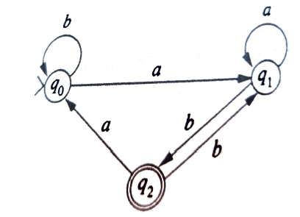
- Construct the transition table of M.
- Which of the strings baba, baab, abab, abaaab are accepted by M?
- Describe the language that is accepted by the automata.
(6 Mark)
- Consider the NFA with ∈ move. Convert it to NFA.
States: Q={A,B,C,D}, Alphabet: Σ={0,1}, Start State: A, Accepting State(s): D
Transitions:
From State | Input (0) | Input (1) | ϵ-Transition
A | - | - | B,C
B | D | C | -
C | C | D | -
D | A | - | -
(5 Mark)
- Minimize the DFA
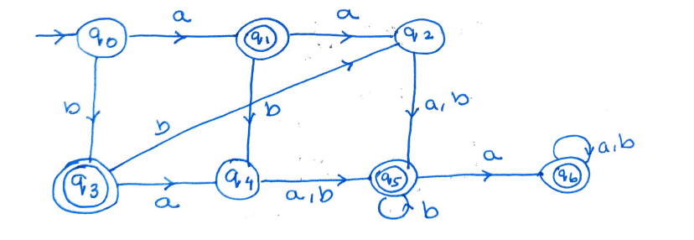
(10 Mark)

